|  |  |
| --- | --- |
| **Test Progressive Assistants** |  |
| Web Design and Programming |
| **For 23-2 Generation** |
| ***Valid on*** *Odd Semester Year 2023/2024* |

1. Peserta TPA tidak diperkenankan untuk:
   1. Mempublikasikan jawaban yang telah dibuat secara sengaja ataupun tidak disengaja.
   2. Membuka dan/atau menyalin jawaban dari buku, video, ataupun peserta lainnya.
   3. Melakukan tindakan yang menyebabkan jawaban dicontek oleh orang lain atau kelompok lain, baik disengaja maupun tidak disengaja.
   4. Melakukan tindakan kecurangan lainnya.
2. Jika peserta TPA dan/atau terbukti melakukan tindakan seperti yang dicantumkan pada butir ke-1, maka nilai TPA yang melakukan kecurangan, baik menyontek atau dicontek, akan dinolkan sesuai dengan peraturan yang berlaku. Dan akan diberikan sanksi sesuai prosedur yang berlaku.
3. Jawaban yang dapat diterima dan dinilai adalah jawaban yang dikumpulkan sebelum batas waktu yang telah ditentukan.

|  |
| --- |
| Jakarta, 09 Januari 2023 |
|  |
| **Justine Winata Purwoko** |
| Assistant Development Officer |

# Soal

*Case*

TraveloHI

**TraveloHI** is a platform for purchasing airplane tickets and hotel room reservations online, use can purchase tickets or book hotels anytime and anywhere. The basic idea of TraveloHI is the same as other e-commerce, there is a buying and selling process, wallet balance, customer support etc. **HI** as CEO of **TraveloHI** is looking for talented web developers through this test. Anyone who can complete all of HI's wishes will be recruited to become a project manager at **TravelHIng.inc**.

To ensure that each contestant does not cheat, **HI** will hold a face-to-face presentation with each test participant. **HI** wants every participant to understand what is made, used and how each feature that has been created works. To ensure that no contestant does anything after the contest ends, **HI** asks the *Assistant Development* for all contestants to send their code to GitHub, and all commits that have passed the deadline will not be considered valid work.

In this project, **HI** requested to use the **GO** language as the backend language and implement a **REST API** and not forget to add API documentation using **swagger**. You are also required to use **React** front-end framework to develop your front-end web application**.**

For the database you must use **PostgreSQL.** You are **free to create and design the database** in any section, but you must have a **strong logical reason why**. There are some factors that you should notice on development such as **performance, security, design, and tools understanding.**

Because this is a contest, **HI** wants everyone to use pure **CSS/SASS/SCSS** to see the design skills of each contestant. It is not permitted to use any type of **CSS** libraries and UI Component libraries. In the design factor, the web design must be responsive with 3 breakpoints, **desktop, tablet,** and **mobile**. Consider the **UX** of the application, because **the experience** is what makes customers loyal to the web, **not the design.**

In the security factor, you are asked to use **JWT Token** for login authentication process. For security reasons, **HI** asks that the same account cannot be logged in in two different places at the same time.

In the tools understanding factor, you are asked to just simply not just use the tools, but

**understand** *what*, *why*, *how,* and anything that *related* to the tools you are using.

**HI** asks all contestants to be able to work on this question happily, don't forget to work on the main features of this question and never be afraid if you find an error, get enough rest, and never stop learning. You can use this following logo or icon for the website:



*Figure 1. Web Logo (Blue Version)*



*Figure 2. Web Logo (White Version)*

Blue means only front-end

Yellow means only back-end

Green means Completed Feature

Here are the **Project Requirements** for **TraveloHI**:

# General

* + Must pay attention to **performance** in the **frontend**, **backend**, and **database**.
  + Must be able to explain the purpose and the reason of the code and action.
  + Must pay attention to **UI** and **UX** for every page.
  + Must implement **swagger** for backend development.
    - Make at least 4 APIs with PUT, POST, DELETE, GET as required HTTP Methods.
    - Must show example value for each API.
    - Make sure the example value can be executed.

# All Page

* + Must have two themes: ***Light* and *Dark****.* And for the **default** theme is *Light* theme.
  + Must be able to **toggle** between those two themes.
  + Must be **responsive** on desktop, tablet, and mobile.
  + Must have proper **authentication** & **authorization**.
  + Must display **Navigation Bar** Component for the **authorized page** for logged-in user.
  + Must display **error message** if an error were to occur.
  + Must be able to change **currency** (USD and IDR)**.**

# Login Page

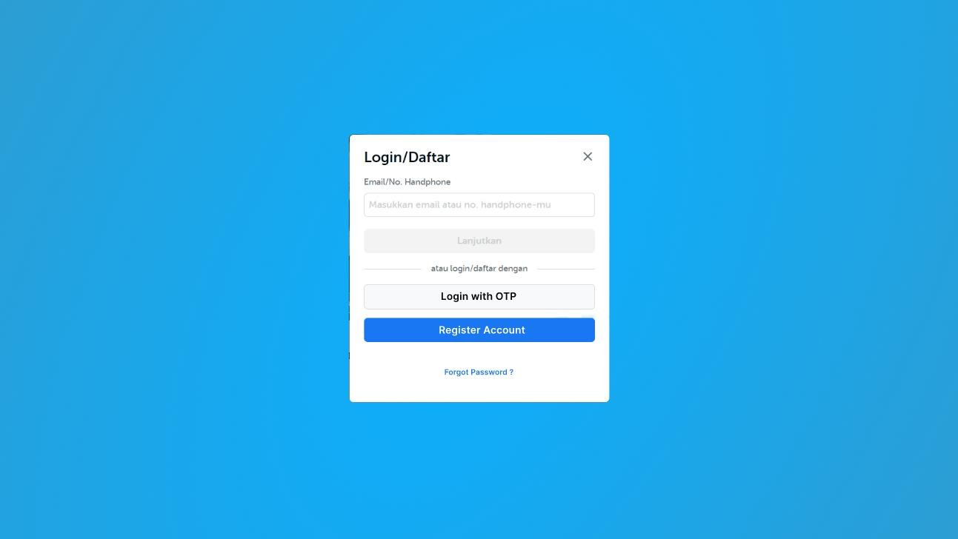

*Figure 3. Login Page*

* + Must **redirect** here if guest were to enter unauthorized page.
  + Must use **email** and **password** to log in.
  + Validate, the email address is not **banned**.
  + Validate, email to match the following pattern **[email name]@[domain].com,** ex:

[**hans.indrawan@gmail.com**](mailto:hans.indrawan@gmail.com)

* + Users can login using **OTP** code.
  + Must only allow **activated account** to log in.
  + Must contains link to **Register Page** and **Forgotten Password**.
  + Implement **reCAPTCHA** to avoid spam.

# Register Page

* + Must register a new **email account** and **password**.
  + User must insert his **personal information** such as first name, last name, Date of birth, password, confirmation password, gender, profile picture and at least 1 personal security question.
  + For personal questions you must create a dropdown by this following list:

1. What is your favorite childhood pet's name?
2. In which city where you born?
3. What is the name of your favorite book or movie?
4. What is the name of the elementary school you attended?
5. What is the model of your first car?
   * The **first name** and **last name** must be **more than 5 characters** and there must be **no symbols or numbers**.
   * User age must be **more than or equal to 13 years**.
   * Validate the user’s **gender** must be **male or female**.
   * Allowed **characters** for **password** are capital letters, lower-case letters, numbers, and special symbols, and has a length of 8 – 30 characters.
   * Users can subscribe to newsletter using checkbox.
   * Send **email to inform** user that users account registered successfully.
   * Must contains link to **Login Page**.
   * Implement **reCAPTCHA** to avoid spam.

# Forgotten Account Page

* + Email must be **registered** and **not banned**.
  + Find the **user security question** and **make user can answer** the security question.
  + Validate **security question answer** is correct.
  + Validate **new password** must not be the same as old password. AYOO WTF
  + Must contains link to **Login Page**.

# Navigation Bar Component



*Figure 4 Navigation Bar Component*

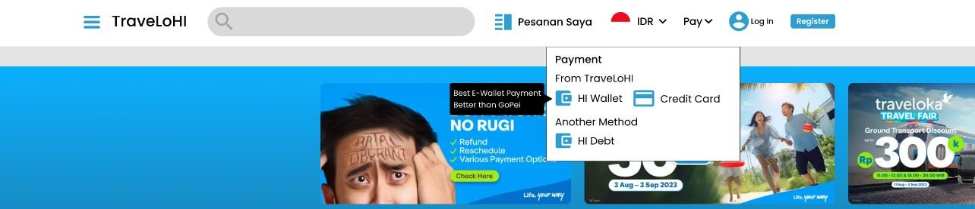

*Figure 5 Available Payment Method*

* + Display currently **logged** in user.
  + Display current language and currency for the page.
  + Validate register or logout button.
  + Must display number of **ongoing ticket** or **hotel reservation**.
  + Show the **available payment method** and its **information**.
  + Navigation bar can search flight airline or hotel (future explanation please refer to

# Search Component).

* **Search Component**
  + Display top 5 **search recommendation** from the most search result.
  + Display 3 recent **search history** from user.
  + Can search either **airlines** or **hotels**.

# Footer Component

* + Must display at least 5 useful links to **external websites**.
  + Must display at least 4 useful links to **internal websites**.

# Home Page

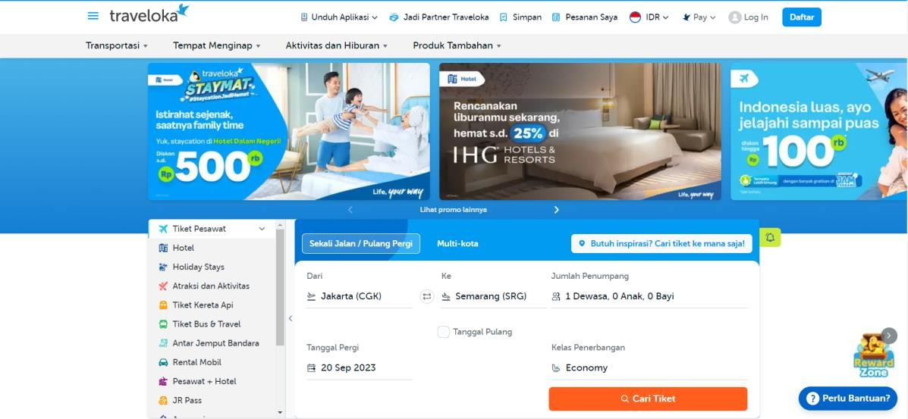

*Figure 6. Home Page*

* + Display at least 4 **ongoing promos** as a slider.
  + Display **Why Travel** with TraveloHI.
  + Display **flight recommendation** based on **top 5 most popular flight destination**.
  + Display **hotel recommendation** based on **top 5 most hotel booked**.

# Search Result Page

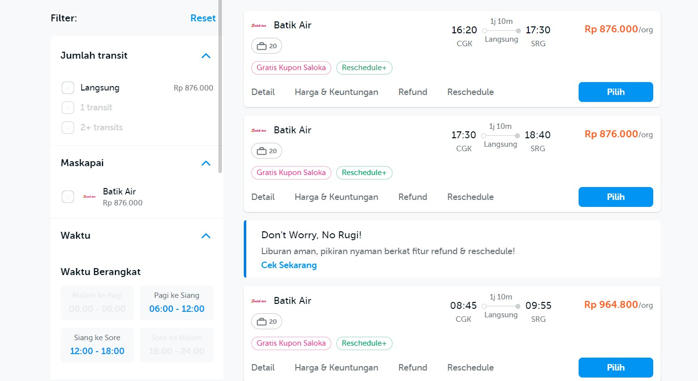

*Figure 7. Create Post Component*

* + Display the result from **search component**.
  + **Paginate** the results with the number of results per page being 20,25, and 30.
  + Can **filter** the result based on **rating** and **price** range.
  + Hotels can be filtered based on **facilities** (swimming pool, restaurant, gym, etc.).
  + Flights can be filtered based on **transit flight** or **not**.
  + Hotels can be sorted based on **rating**, **price**, **number of reviews** and **room availability**.
  + Flights can be sorted based on **duration**, **price**, and **number of transits**.

# Detail Page for Flight Ticket

* + Display **airline**, **airplane code**, **origin airport**, **destination airport**, **flight duration**, **departure date**, **arrival date**, and **seat availability** for each available seat class.
  + Display the **seat map** for easier seat choosing, please give information about seat status (booked or available) and seat class.
  + Users can choose to **add on luggage**.
  + Display **total price**.
  + Users can choose to **buy now** or **add to cart**.

# Detail Page for Hotel Booking

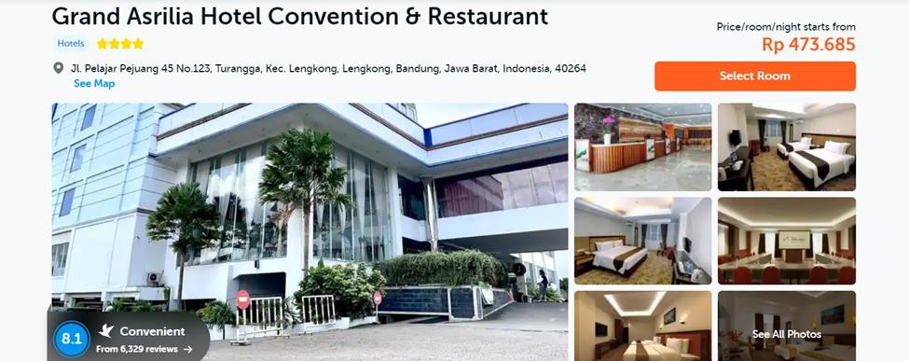

*Figure 8 Detail Page for Hotel Booking*

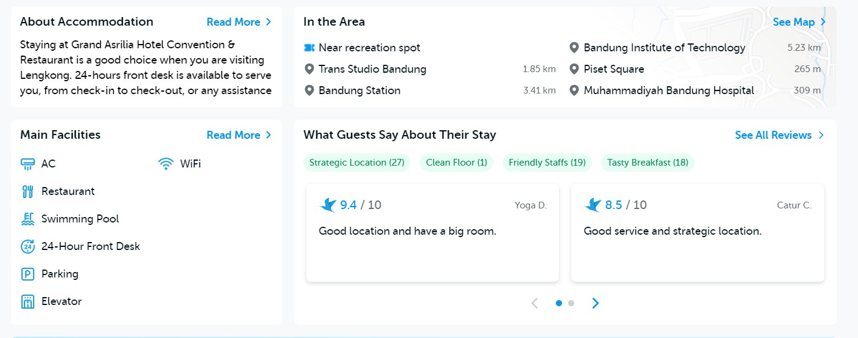

*Figure 9 Detail Page for Booking Hotel Review Example*

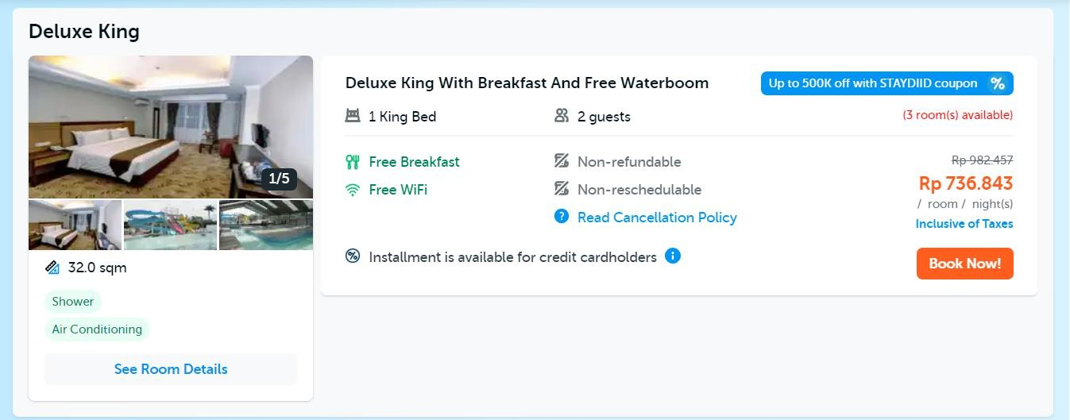

*Figure 10 Detail Page for Booking Hotel Available Room Example*

* + Must display **hotel’s descriptions**, **pictures**, **hotel’s names**, **ratings**, **addresses**, **number or reviews**, **hotel facilities** and **price** per room category.
  + Display all **hotel’s review**, if users choose to submit review as anonymous do not display the **name** and **profile picture**.
  + User can choose to **check in date** and **check out date**.
  + Display all room **types**, **prices**, and **facilities** (ex: Junior suite, Rp 400.000/night, non- smoking, free drinking water, bathtub).
  + Display hotel’s **ratings** are divided into **cleanliness**, **comfort**, **location**, and **service**, also display average from all hotel’s rating point.
  + Users can choose to **add to cart** or **buy now**.

# Cart Page

* + TraveloHI adopt several statuses for **flight ticket** and **hotel booking**, **ongoing ticket** or **booking means** the reservation date has **not passed** the **current date** and expired means the reservation date has **passed** the **current date**. Artiny apa
  + Display all **flight destinations** and **hotel books** from **user’s cart**.
  + Users can update **check-in** or **check-out** date for hotel.
  + Display **price** per item in the cart.
  + Display **total price** in the cart.
  + Display **the status** from the **ticket** and **validate user** cannot check out for flight tickets and hotel books with expired status.
  + Users can **add promo code** and each user can only **use once per promo code**.
  + Users can choose **payment method** (HI-Wallet or credit card).
  + If a user chooses **a credit card** as a **payment method** validate that credit card already registered.
  + Send **payment** details using **email** to user if the **payment successful**.

# My Ticket Page

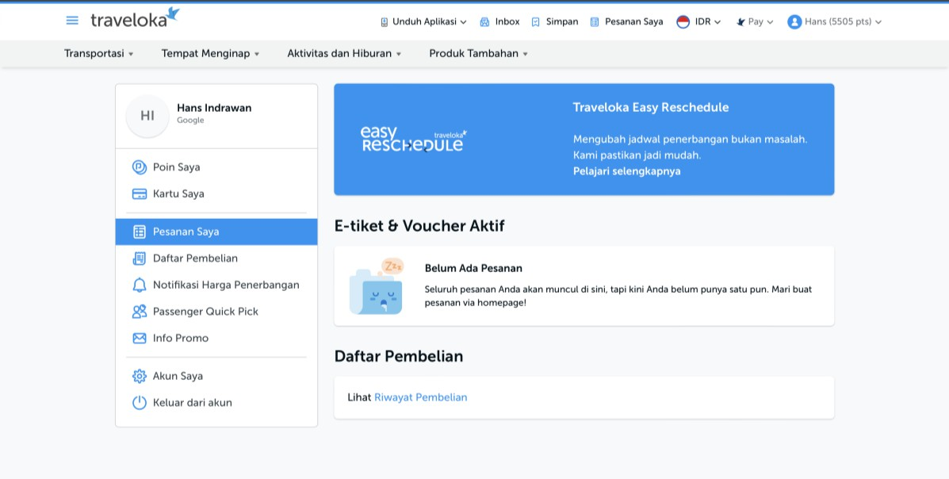

*Figure 11. Ticket Page*

* + Display **all paid** and **ongoing flight tickets** or **hotel bookings**.
  + Users can search for **flight tickets** or **hotel bookings** based on the hotel’s name, airline,

or flight code.

* + Filter based on ticket **flight** or **hotel bookings**.

# History Page

* + Display all **paid** and **expired flight tickets** and **hotel bookings** with **infinity scrolling**.
  + Users can search for **flight tickets** or **hotel bookings** based on the **hotel’s name**,

**airline**, or **flight code**.

* + Filter based on **ticket flight** or **hotel bookings**.
  + Users can give **reviews**, **ratings** and **choose to submit anonymously**.

# Profile Page

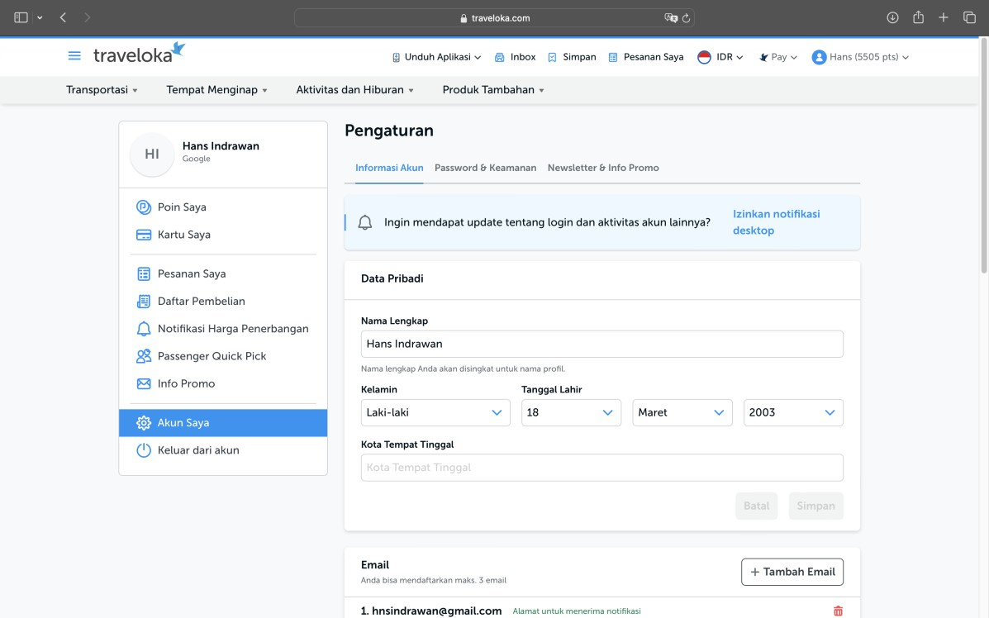

*Figure 12. Profile Page*

* + Display all the **personal information** such as **first name**, **last name**, **profile picture**, **phone number**, **email address**, **address**, and **subscription to newsletters status**.
  + Users can **update** all the **personal information**. (Kecuali profile picture)
  + Users can choose to **subscribe** to newsletters or **unsubscribe** to newsletters.
  + Users can **add credit cards** and **bank details**.
  + Users can **log out**.

# Admin Page

* + Validate, only admin can access this page.
  + Admin can **update ongoing promos**.
  + Admin can **insert** new **hotel** and **airline**.
  + Admin can **insert** new **promo code**.
  + Admin can **view all users** and **ban** the account.
  + Admin can **send email** to **all accounts** that **subscribe** to newsletter.

# Check Location Page

**HI** believes that to make TraveloHI used by many people, it needs unique features in the application, here are the additional feature specifications:

* + Make a **deep learning model** that can learn from given dataset.
  + Must use **AlexNet model** and make some necessary adjustments to your model.
  + Save your model to **.pkl** or **.h5**.
  + User can **send picture** from **front end** and **send the picture** to the **model’s backend**

and then return picture’s location.

* + Automatically display **available flight** or **hotel** in **picture’s location**.
  + Make sure to **UNDERSTAND** your **model** code.
  + You are **permitted** to **add** or **make** some adjustment to the model, as long as you already have the base code for AlexNet model.

# Multiplayer Game

During designing the **TraveloHI** web concept, **HI** saw that its competitors were providing unique features in the form of games that could be played by users, **HI** saw this as an **opportunity** to win the hearts of its competitors' consumers by **making games** that were more exciting than **Tjotjoki** chose **Shoofy**, therefore **HI** wanted you to make unique game.

Here is a list of some of the features needed to create the game:

* + Must use **web socket** to make **online multiplayer game**.
  + Validate users that can play **must be registered** in the TraveloHI database and the winner will be **given a prize**.
  + If the user is valid, **automatically join** to the room (there is only a room available, so there are only 2 players playing at the same time).
  + Automatically **remove a player** from the match when a player **disconnected**.
  + Players can only **play 3 times** for **every 10 minutes**.
  + Display **player sprite**, **enemy sprite**, **player health bar**, **enemy health bar**, **timer**, **background**.
  + Every **player’s action** and **enemy’s action** must be **animated**.
  + Players can **move left** and **right**, **jump**, **low kick**, **front kick** and **idle**.
  + To match the mood between players, **play background music** when a player joins the game. Make sure the volume is not too loud.
  + Low kick is achieved when user pressed **‘s’** and **‘space’** key together. This move has

**15 damage** to the enemy.

* + Front kick is achieved when user pressed **‘d’** / **‘a’** (depend on the player position and enemy position) and **‘space’** key together. This move has **10 damage** to enemy.
  + Each player has **100 hp**.
  + Automatically **changes the direction** of the sprite according to the enemy's position.
  + Implement **Framerate Per Second** (FPS) on the game with 60 base **FPS**.
  + Show game result, **‘Win’**, **‘Lose’** or **‘Tie’** if time runs out and no player has run out of health.
  + After the **game ends**, validate that all the players **cannot move**.
  + To simplify the presentation process, please **display the collision box**.

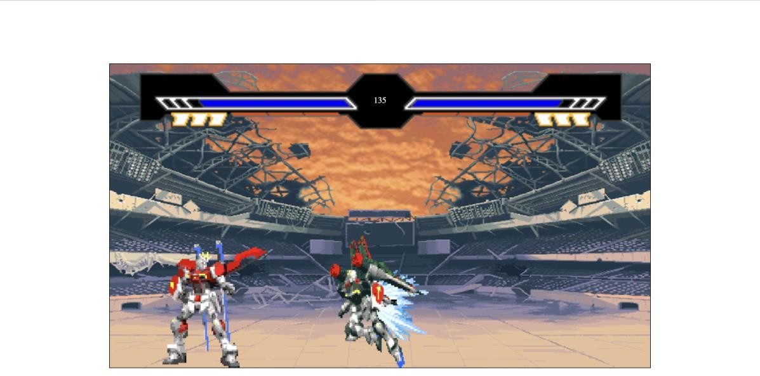

*Figure 13 Gameplay of the Game*

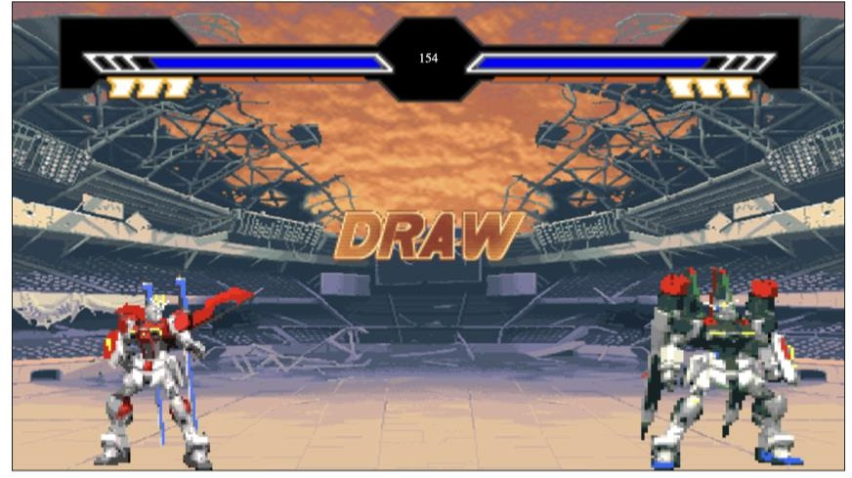

*Figure 14 Draw Condition*

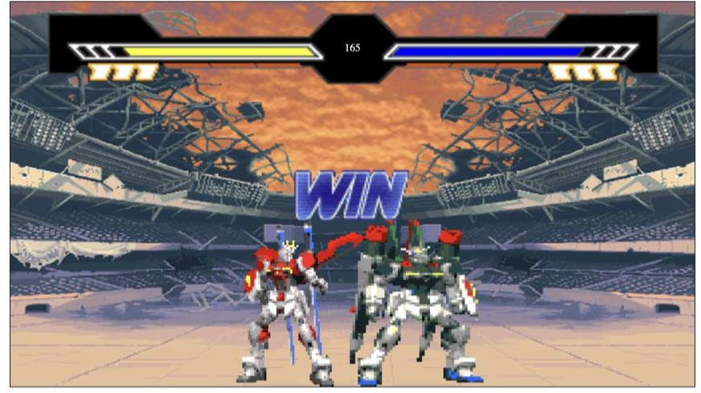

*Figure 15 Winning Condition*

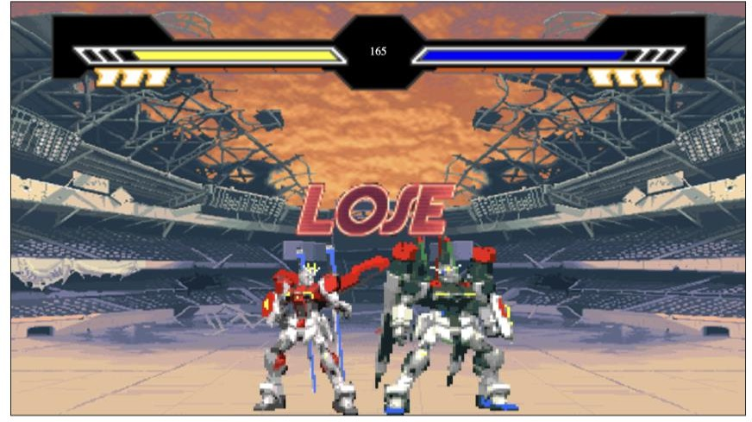

*Figure 16 Losing Condition*

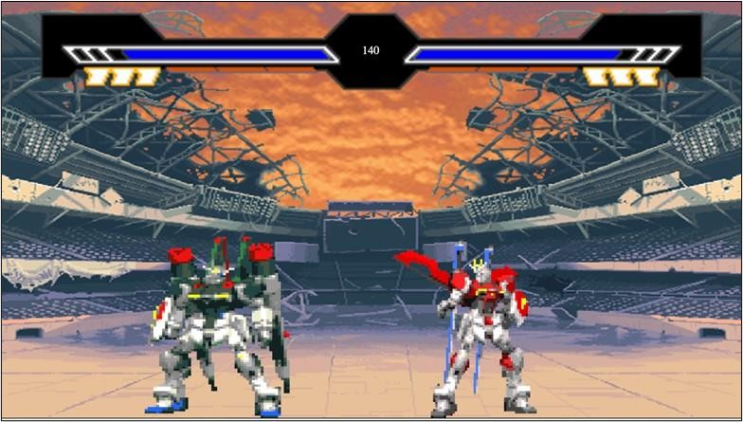

*Figure 17 Automatically Change Sprite Direction*

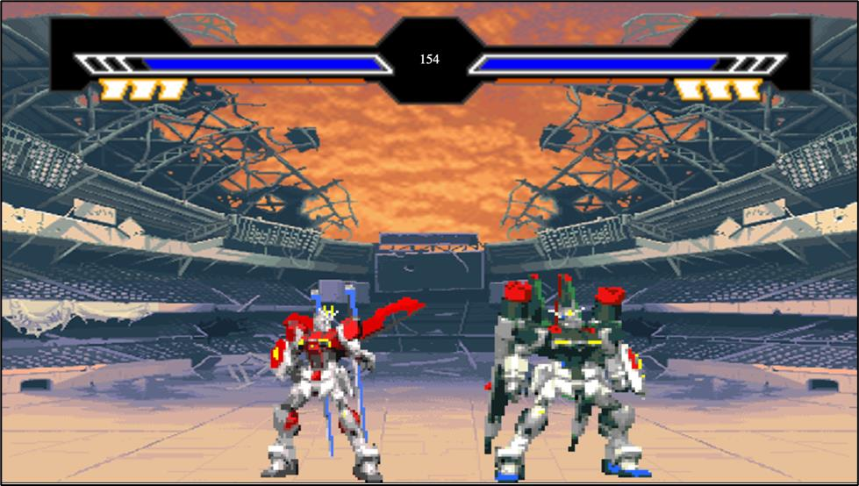

*Figure 18 Initiate Game UI*

# Additional Note

* + Users get **initial balance** for HI-Wallet.
  + **Coupon code** can be used to add HI-Wallet balance.
  + Contestant allowed to use **another sprite** for the game.